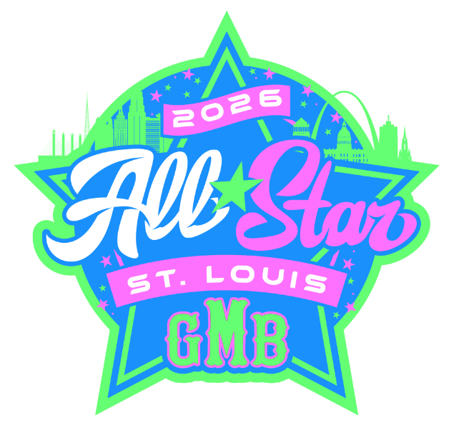

2026 Team Practice Field Assignments
Field #1
9U Blue - Willis
9U Pink - Portz
9U White – Wehrle
9U Green – Jockisch

Field #2
10U Blue – Shipman
10U Pink – Schaper
10U White #1
10U Green – Bockewitz
Field #3
10U Blue #2
10U Pink – Zwicker
10U White – McGregor
10U Green – Benfatto

Field #4
11U Blue – Neece
11U Pink – Dolmage
11U Green – Peters
11U Blue – Irwin

Field #5
11U Pink – Hayes
11U White – Nichols
12U Blue #2
12U White #2

Field #6
12U Pink – Porch
12U Green #1
12U Blue – Heyen
12U Pink #2

Field #7
13U Blue – Mott
13U Pink – Moore
13U White – Chisam
13U Green - Blakenship

Field #8
11U White #1
12U White #1

Field #9
14U Blue – Hawkins
14U Pink – Gamblin
14U White – Workman
14U Green – Pelikan/Palmisano

Field #10
8U Blue – Bibas
8U Pink – Cyr
8U White #1

