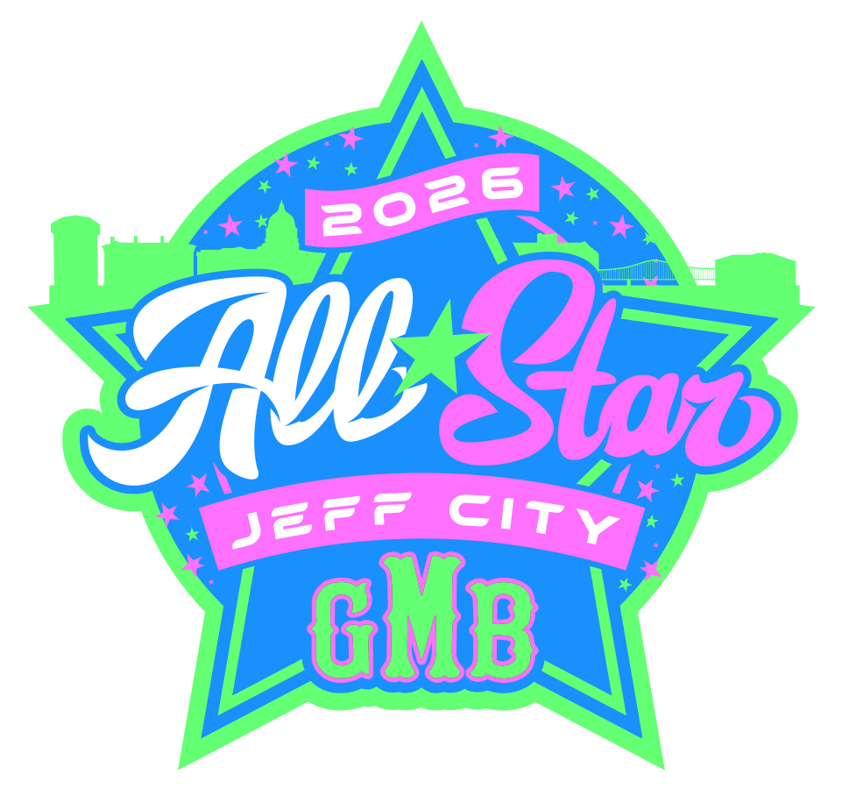

2026 GMB Skills Competitions Rules

Location : Mid America Bank Sports Complex – Jeff City, MO
Skill Qualifying Begins @ 1pm
*Assigned Time and Fields Are Posted On The Schedule*
Events:
*Home Run Derby*
*Catcher’s Pop Time*
*Pitcher’s Golden Arm*
*Fastest Man In The World*

Leaderboard can be seen via Playboo365

**See Event Break Downs Below**
Please Note Events may NOT be completed in this order

- Home Run Derby:
*ALL PLAYERS NOT HITTING IN THE HRD ARE REQUIRED TO BE IN THE OUTFIELD SHAGGING BASEBALLS.
Top Two Players Per Age Will Qualify For The Finals Held After the Team Parade
Rules:
- All players will have 60 second to hit as many homeruns as possible
Tiebreakers:
- If tied after round 1 we will a swing off consisting of 5 swings
- If tied after (A) we will repeat until a winner is crowned

*If NO player hits a home run after round 1 is complete the GMB rep will determine what player(s) hit the farthest balls IN THE AIR and they will move on to Tiebreaker A.

- Fastest Man In The World
Scoring: Timing - Best Time Wins
Description: Each player will run Two (2) 60-yard Dash
Rules:
- Time starts on players first movement
- Time stops when crossing the finish line
Tiebreakers:
- If tied after round 1 we will do a head-to-head sudden death final

- Pitcher’s Golden Arm
Scoring: Accuracy – Best Score Wins
Description: Each Pitcher will get 5 throws to score the highest total they can
Tiebreakers:
- If tied after round 1 we will do 3 more throws
- If tied after (A) we will repeat until a winner is crowned
Scoring: See Target Below

- Catcher’s Pop Time:
Participants Are Limited To Catchers ONLY
Scoring: Timing Event – Best Time Wins
Description: Each Player will get 4 throws from Home Plate To Second Base
Rules:
- Player must be in a normal catcher’s position
- Player must be BEHIND home plate
- Time Starts when the ball hits the catcher’s mitt
- Time STOPS when the ball hits the glove of the fielder at second base
Tiebreakers:
- If tied after round 1 we will do a 2 more throws
- If tied after (A) we will do a 1 more throw
- If tied after (B) we will repeat until a winner is crowned

